**IT 1090C Computer Programming I   
Lab 11: ListMaker   
SPRING 2020**

**20 pts (No Extra or Grad Options)**  
  
Learning Goals:

* Work with the ArrayList to create a dynamic list
* Develop additional one-off static private support methods for this program
* Use the SafeInput library we created for the input

**Mini-lecture:**

ArrayLists are similar to arrays but are dynamic and flexible. ArrayLists only hold objects so you have to use one of the java object wrapper classes for an arraylist of primitives (Integer, Boolean, Double, etc...) For this assignment, our ArrayList will be of type String.  
  
**import java.util.ArrayList; //** required for using

* Create a new ArrayList:  
    
  **ArrayList<String> myArrList = new ArrayList<>();** // note the diamond notation on the type parameter <>
* Add and element to the end:  
    
  **myArrlist.add(“Some String”);**
* Read an element at location m which is an index just like an array  
    
  **String var = myArrList.get(m);**  // again m is the index which is zero based as in the arrays
* Insert an element at location m  
  **myArrlist.add(m, “Some String”); //** again m is an index like an array
* How many items does the arrayList hold:  
    
  **myArrList.size();**
* Overwrite or replace an item at index m:  
    
  **myArrList.set(m, “New String Value”);**

**Directions:**

1. Start by creating a menu driven loop:
   1. The Loop awaits user input until the Quit command is issued
   2. Options:  
      A – Add an item to the list  
      D – Delete an item from the list

P – Print (i.e. display) the list

Q – Quit the program should do an are you sure? type query before exiting.

* 1. The program gets one of these commands from the user and executes that function
  2. Initially stub out the functions so you have a program that you can run almost immediately as you develop it as per the Agile Software Dev approach. You will develop each of the menu options as a separate java method.
  3. You also will need some private static utility functions.
     1. You will want to display the current list along with the menu of options so the user can see what they are doing.
     2. You need to display a numbered version of the list to allow users to pick list elements for deletion. Here the user looks at the display and then indicates the item to delete by the number.
  4. You should use your **SafeInput** library to bulletproof all input.   
     For instance, use your getRegExString method to get the menu choice from the user.  
     Here, a regEx pattern like this [AaDdPpQq] creates a set of where a match will be one of these characters which of course are the menu choice that they user will make.. Note that we have to include both the upper and lower case.  
       
     Use your getRangedInt method to get the item number to delete, etc.  
     Use your getYNConfirm method for the quit prompt etc.

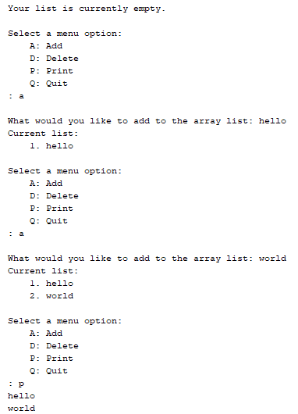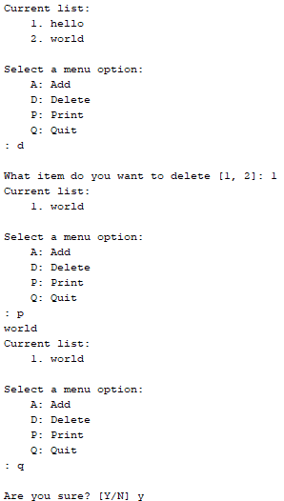

**Submit your work:**   
  
Rename this word doc with your embedded screen shots as Lastname_Firstname_Lab 11 ListMaker.docx. Zip it all up with a complete copy of your Netbeans project. Name the Zip file: Lastname_Firstname_Lab 11 ListMaker.zip. Submit your archive and the separate docx file with the Canvas assignment mechanism.